Progress log

Added density adjustment slider for spray can tool, adapted from stamp tool’s spacing adjustment slider.

Removed ‘Fixed density?’ checkbox option since density for spray can is more often changed.

Changed spray can drawing from per size to per density value. (change highlighted below). Also added x8 multiplier to make the density changes more pronounced visually.

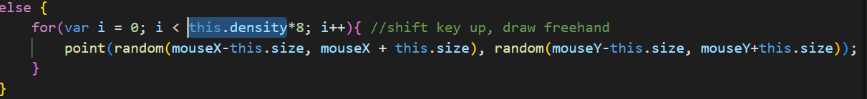

Example of usages (the units are random theoretical units and are not related to usual units used in raster programs such as cm/px:

1. Density: 30 (default)

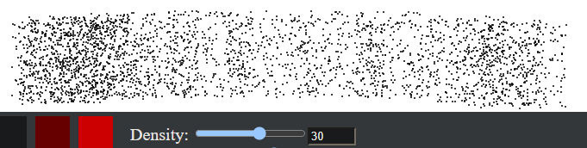

1. Density: 1 (minimum)



1. Density: 50 (maximum)

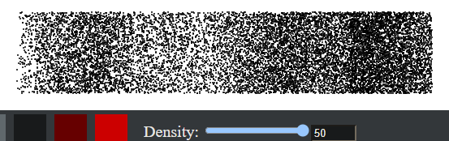

Fixed spacing slider being reset to 0 upon changing tool back to stamp tool.

Changed to

Issue: alternate mode of rectangle tool unable to expand towards top right and bottom left due to lack of conditionals to control drawing.



To:

Improvement idea: The rendered square only scales horizontally to mouse placement (red dot in image below represents end cursor placement). The accuracy can be improved easily by making use of the Pythagoras’ theorem (d = $a\sqrt{2}$), and making the square scale in both directions to the length of the square based on the diagonal distance of the mouse from the start point.

This method also makes the code cleaner and easier for a human to read. I thought it would make the program move slower because there are more calculations, but it is just as smooth as the previous method.